PROGRAMMING ASSIGNMENT
NAME : BARU RAVI VARMA
ROLL NO : 14AE10007
CASE A :
PROBLEM 1:
Turbojet without an afterburner
CODE :
%Programming Assignment
%Case :A -> Turbojet without a after burner
%case A: Problem 1

% NAME : BARU RAVI VARMA
% ROLL NO: 14AE10007

%%ASSUMPTIONS : GAMMA VALUE IS CONSTANT AND EQUAL TO 1.4
%%CODE
clc;
clear all;
%GIVEN
Ma = 0.75; %Mach Number
r = 1.4; %gamma value
P = 6; %Tt4/Tta
N = 150 ; %del H/Cp*Ta

%%
Q = 1+ ((r-1)/2 ) * Ma*Ma; %Tta/Ta
i = 1;
for CPR = 5 : 2.5 : 25; %Compressor pressure ratios
CTR = CPR.^((r-1)/r); %Compressor Temperature ratios
j = (Q/(Q-1));
k = (P/(Q*CTR)) - 1;
l = (CTR-1) ;
m= (P/(Q*CTR));
us = j*k*l+m;
NDT(i) =[ Ma * ( sqrt(us) - 1)]; %Non Dimensionalised thrust
Nr = ( P - Q*CTR)/(N*Ma) ;
TSFCa(i) = Nr/( sqrt(us) - 1); %Thrust specific fuel consumption * aa
i = i+1;
end
CPR = 5 : 2.5 : 25;
NDT;
TSFCa;
[AX, AX1, AX2]=plotyy(CPR, NDT, CPR, TSFCa) %PLOTTING AND OBTAINING AXES HANDLE
ylabel(AX(1),'Non Dimensionalized Thrust') %LABEL LEFT X- AXIS
ylabel(AX(2),'TSFC*aa') %LABEL RIGHT Y-AXIS
xlabel(AX(2),'COMPRESSOR PRESSURE RATIO') %LABEL X-AXIS
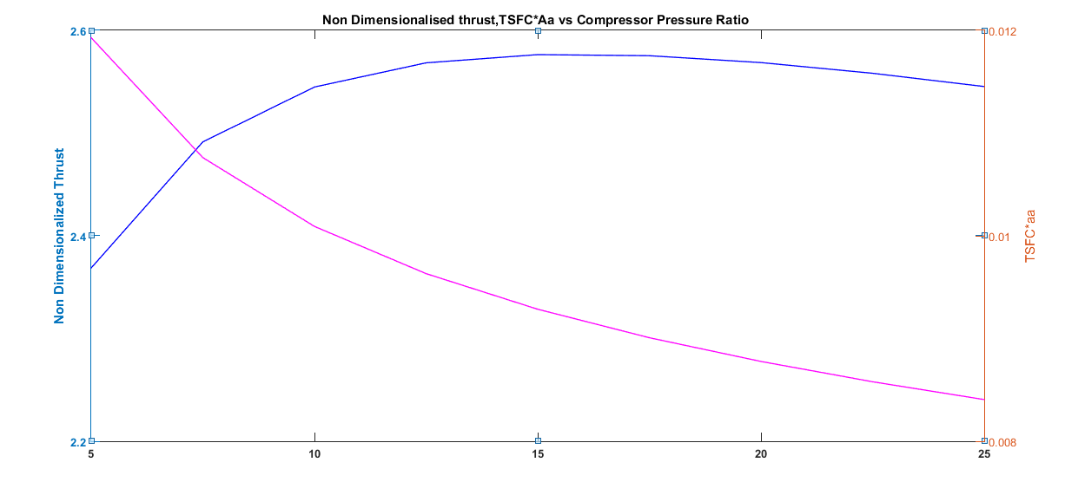
GRAPH :

ANALYSIS :
In this assignment we are interested to find out how dimensionless thrust changes by changing the compressor pressure ratio, as compressor pressure ratio changes compressor temperature ratio also changes. we have derived the relation between these parameters
Also we are finding how Thrust Specific fuel consumption * Aa changes by varying compressor Temperature ratio (which depends on Compressor pressure ratio) by
So developing a matlab code and observing the plots gives us these conclussions :
1) Non Dimensionalised thrust gets increased as the compressor pressure ratio is increased upto certain level and became constant to certain extent ranges of compressor pressure ratios and later if further increased it; it is getting decreased but at very slow rate.
2) TSFC*a_{a} gets decreased as the compressor pressure ratio gets increased rapidly upto certain compressor pressure ratio but later it decreased at a slower rate.
3) Graph is not very smooth because we have less data points because we are taking step size as 5 but if we take a less step size the curve would be more smoother.
4) Assumptions made :
a) Value of γ = 1.4 and is constant through out.

